Name

Full working out must be shown to get full marks.
Attempt all questions
Total Time: 60 minutes
- Section 1 (Calculator Free): 40 minutes 39 marks
- Section 2 (Calculator Assisted): 20 minutes 17 marks

Calculator Free
Question 1 [2, 2, 3 = 7 marks]

- Rewrite the equation y = 2(x – 4)² + 7 in the form of y = ax+ bx + c

- For the graph y = ax² + x – 1 determine the value of a if the graph passes through
the point ( - 4 , 11 )

- The graph of y = x2 + px +q has a turning point at (6, -3). Determine the coordinates of the y -intercept of the parabola.

Question 2 [1, 1, 1, 2, 2 = 7 marks]

- What are the coordinates of the -intercept of the graph of ?

- State the number of roots of the graph of .

- What are the coordinates of the turning point of the graph of?

- What is the equation of the line of symmetry of the graph of ?

- Determine the equation of the quadratic function that passes through the point (0, -9) and has a turning point at (-2, 3).

Question 3 [2 Marks]
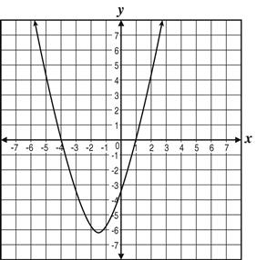
The graph of is shown.
Determine the value of b

Question 4 [6 marks : 2, 2, 2]
Express the quadratic equation ${y=x}^{2}-8x+15$in the form:
a) $y=a(x-b)(x-c)$ b) $y=a{(x-b)}^{2}+c$

c) Solve the equation $x^{2}-8x+15=0$using the quadratic formula

Question 5 [2, 2, 6 = 10 marks]

A quadratic function is given by $f\left(x\right)={\left(x-2\right)}^{2}-9$ .

a) The function can also be written in the form $f\left(x\right)=x^{2}+bx+c$ .
Determine the values of $b$ and $c$ .

b) Solve the equation $f\left(x\right)=0$ .

c) For the graph of $y={\left(x-2\right)}^{2}-9$ , state:

  - The coordinates of the turning point.

  - The equation of the line of symmetry.

  - The coordinates of all axes intercepts.

  - Draw a sketch of the graph using the above information

Question 6 [7 marks : 1, 2, 2, 2]
For the equation y = 2x² - 4x + 6 determine;
- the y-intercept

- the line of symmetry

- the coordinates of the turning point

- Use the discriminant to determine the number of solutions.

- Draw a sketch of the graph using the above information

Mathematics Methods
Semester 1 2017
Calculator Assumed

Question 7 [8 marks]
Complete the table below.
Rule | y−intercept | roots | line of  symmetry | turning  point
y = 15x²− 11x − 12
 |  | (6,0) and (-2,0) |  | ( ___ , -8)

Question 8 [3 marks]

Isabel throws a ball for her dog to catch. The path of the ball is parabolic and can be modeled by the equation where h is the height in metres of the ball above the ground and x is the horizontal distance of the ball from Isabel.
If Isabel’s dog is 4m away from her, how far does he have to jump to catch the ball?
Provide a sketch to illustrate your answer.

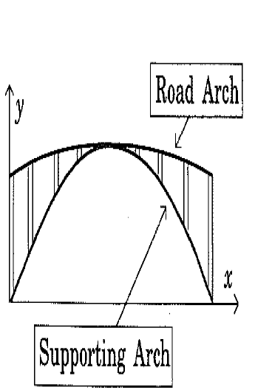
Question 9 [1 + 1 + 2 + 2 = 6 marks]
A road bridge is to be constructed over a tidal river. The road arch is in the shape of a quadratic function, as is the supporting arch (see diagram).

With x and y axes as shown, the equations of each arch are as follows:

Road arch: $y=-\frac{x^{2}}{2250}+\frac{2x}{15}+40$

Supporting arch: $y=\frac{2x}{3}-\frac{x^{2}}{450}$

[1 metre = 1 unit on each axis]

The x-axis is the mean water level with high and low tide levels being four metres either side of this mean.

a) Are the road arch and supporting arch, concave up or concave down?

b) Calculate the value of x at the mid-point of the bridge.

c) Calculate the length of the vertical strut between the support arch and the road arch at a point
one-quarter of the way along the bridge.

d) Calculate the maximum clearance between the water and bridge at:
i) low tide. ii) high tide.

End of Test

